**HRC ID: HRC70936W**

**HRC70936W**

import java.util.ArrayList;  
import java.util.List;  
  
public class Solution {  
 public static void main(String[] args) {  
  
 List<Integer> list = new ArrayList<Integer>();  
 list.add(2);  
 list.add(3);  
 m(list);  
 public static void m (List < Number > list) {  
 System.*out*.println(list);  
 }  
 }  
}

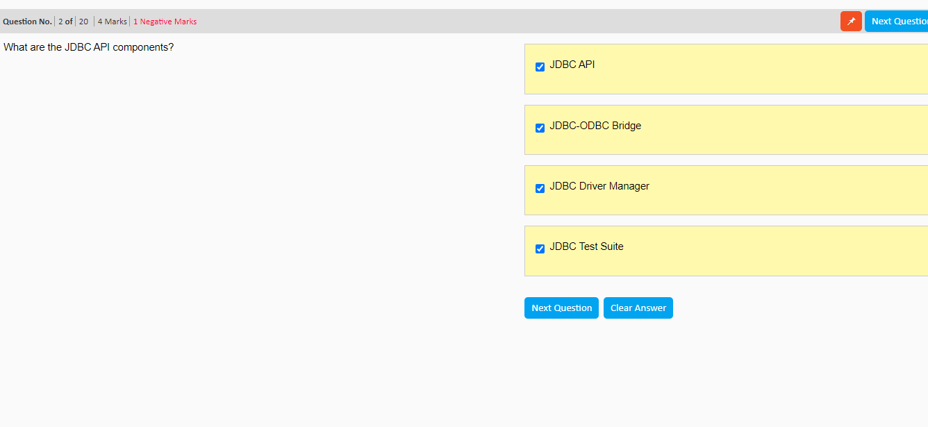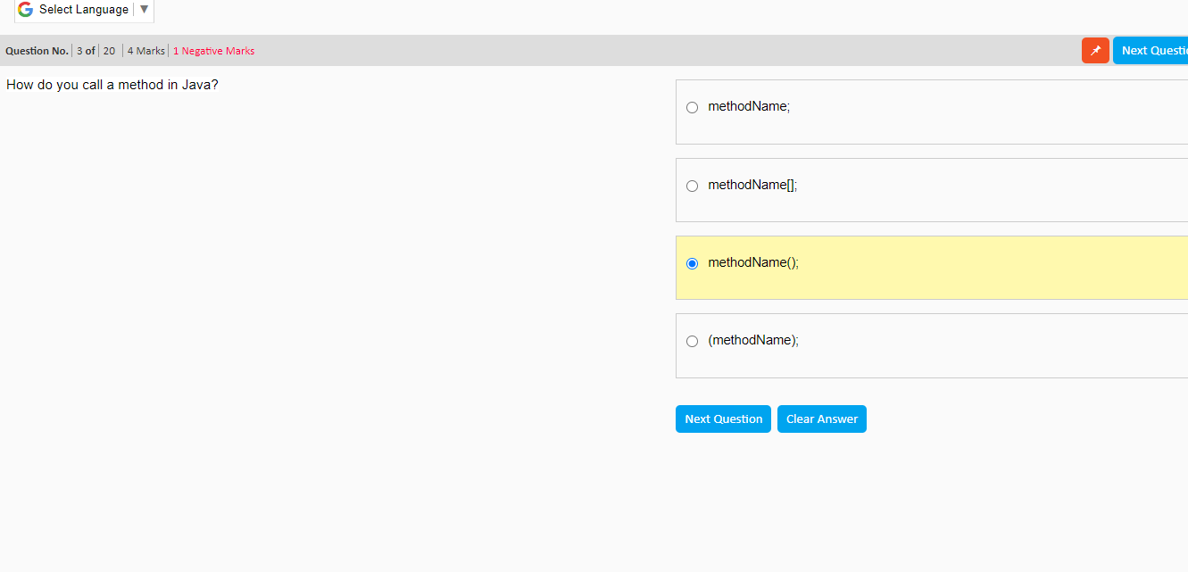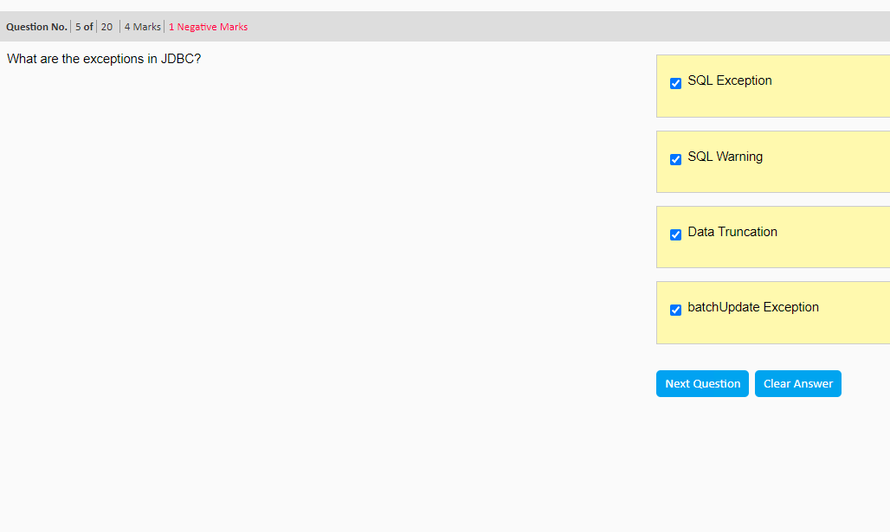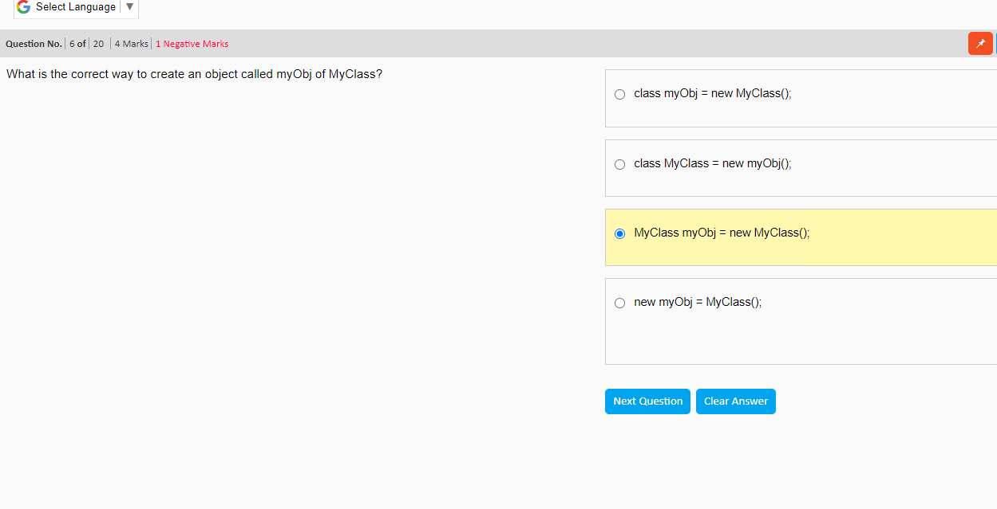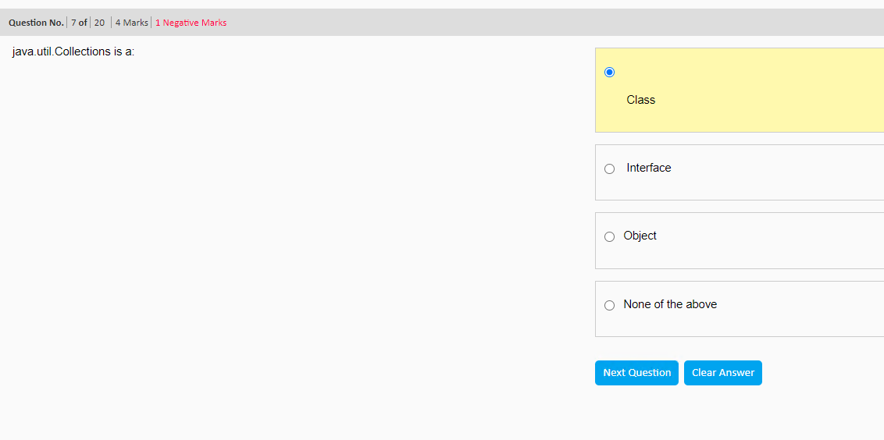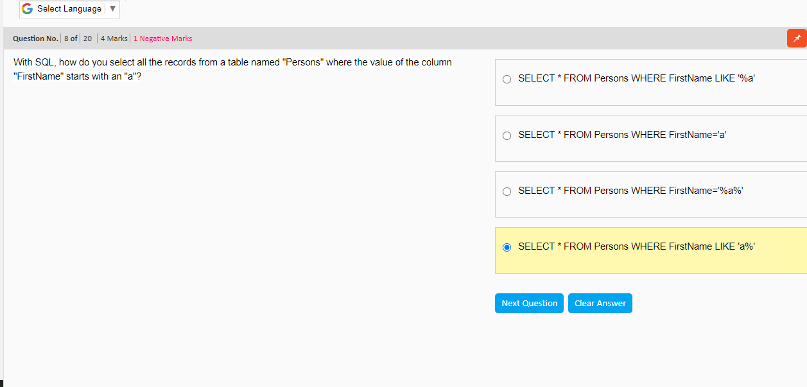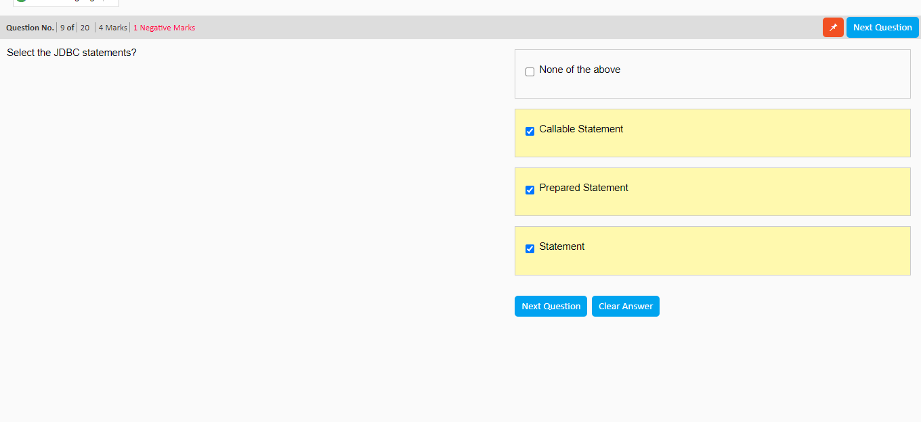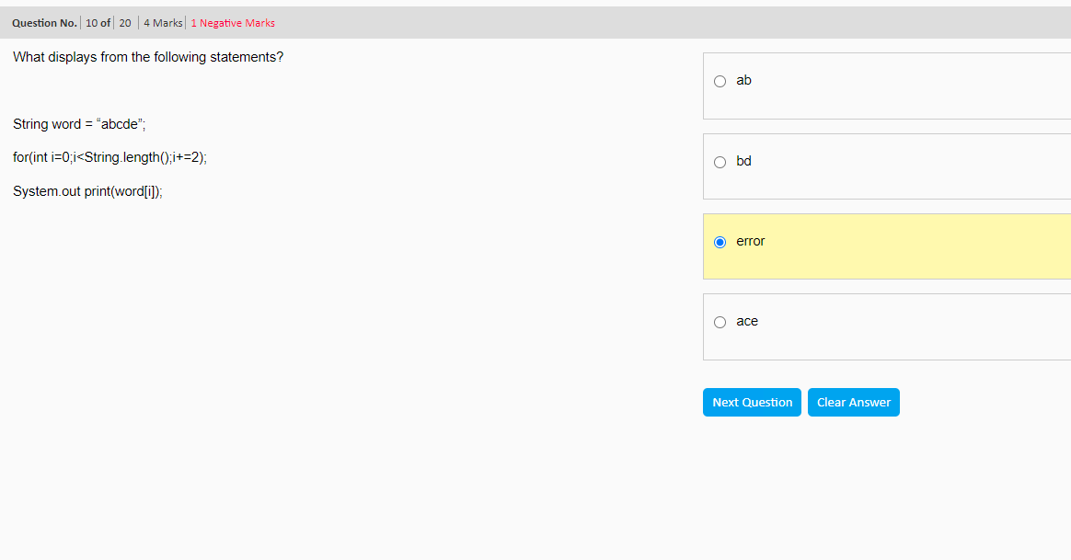

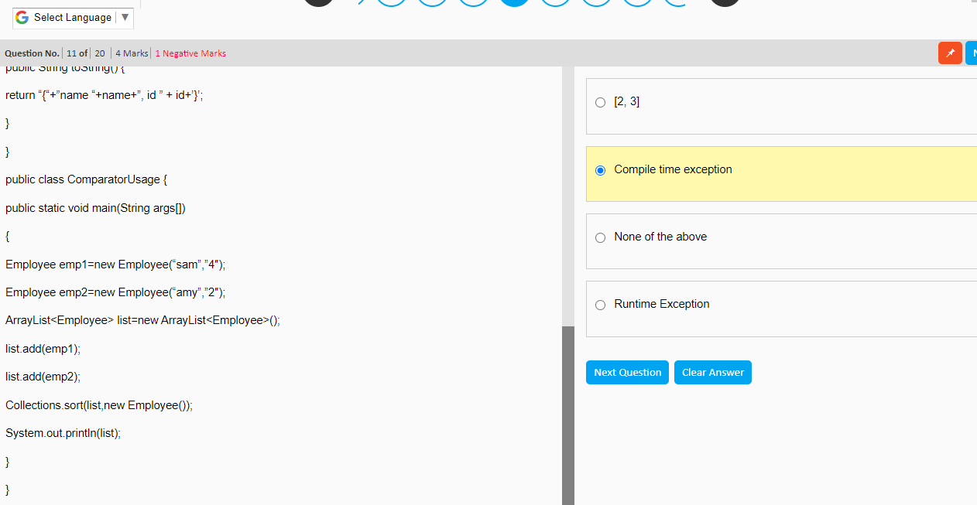

import java.util.ArrayList;  
  
import java.util.Collections;  
  
import java.util.Comparator;  
  
class Employee implements Comparator {  
  
 String name;  
  
 String id;  
  
 public Employee() {  
 }  
  
 public Employee(String name, String id) {  
  
 this.name = name;  
  
 this.id = id;  
  
 }  
  
 public int compare(Employee obj1, Employee obj2) {  
  
 return obj2.name.compareTo(obj1.name);  
  
 }  
  
 @Override  
  
 public String toString() {  
  
 return "{" + "name " + name + ", id " + id + '}';  
  
 }  
  
}  
  
public class Solution {  
  
 public static void main(String args[]) {  
  
 Employee emp1 = new Employee("sam", "4");  
  
 Employee emp2 = new Employee("amy", "2");  
  
 ArrayList<Employee> list = new ArrayList<Employee>();  
  
 list.add(emp1);  
  
 list.add(emp2);  
  
 Collections.*sort*(list, new Employee());  
  
 System.*out*.println(list);  
  
 }  
  
}

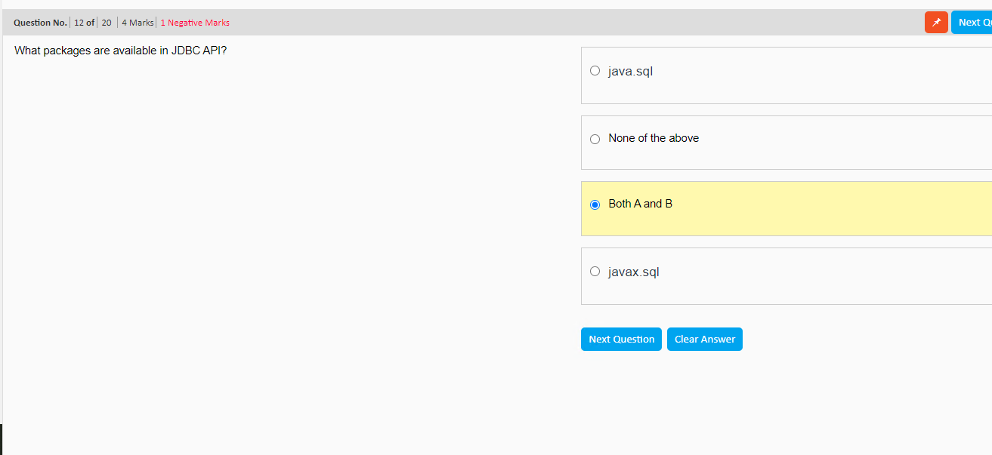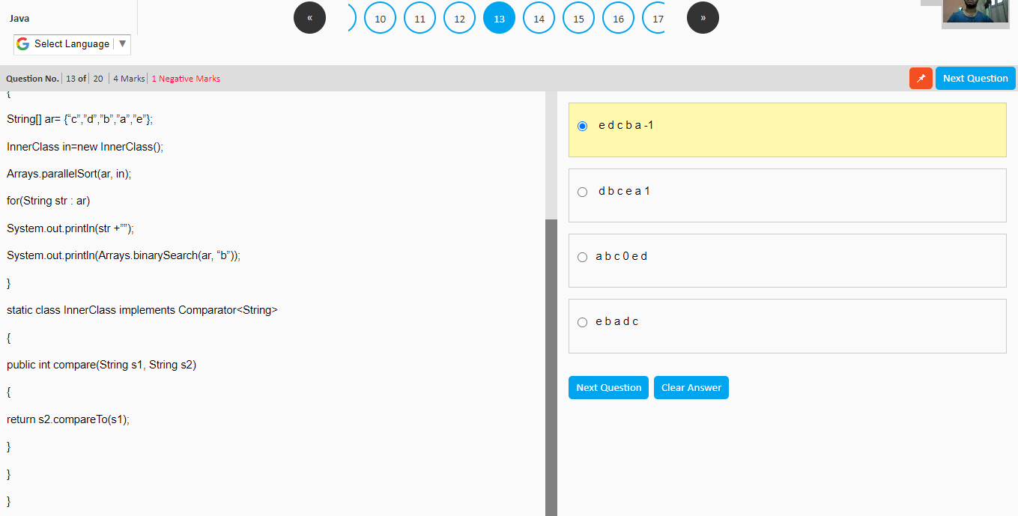import java.util.Arrays;  
import java.util.Comparator;  
  
public class Solution {  
  
 public static void main(String args[]) {  
  
 String[] ar = {"c", "d", "b", "a", "e"};  
  
 InnerClass in = new InnerClass();  
  
 Arrays.*parallelSort*(ar, in);  
  
 for (String str : ar)  
  
 System.*out*.println(str + "");  
  
 System.*out*.println(Arrays.*binarySearch*(ar, "b"));  
  
 }  
  
 static class InnerClass implements Comparator<String> {  
  
 public int compare(String s1, String s2) {  
  
 return s2.compareTo(s1);  
  
 }  
  
 }  
  
}  
  
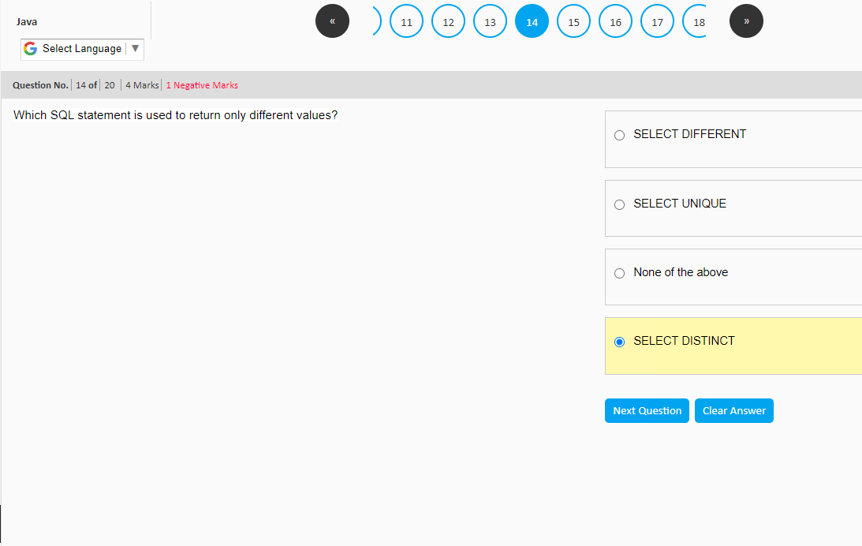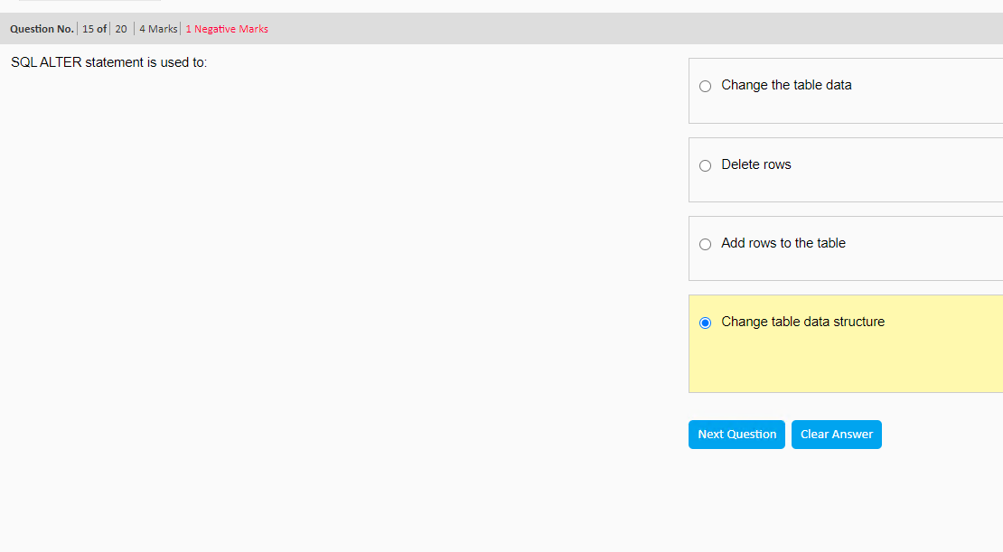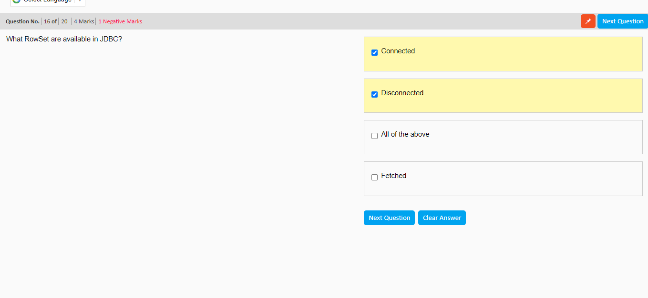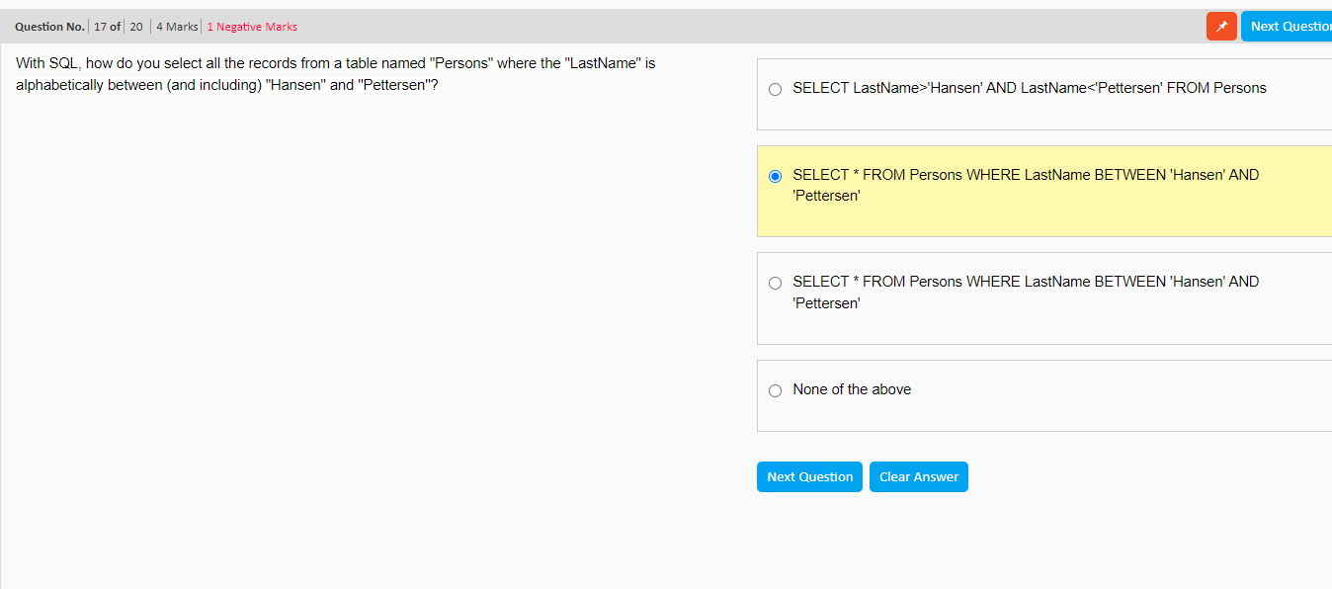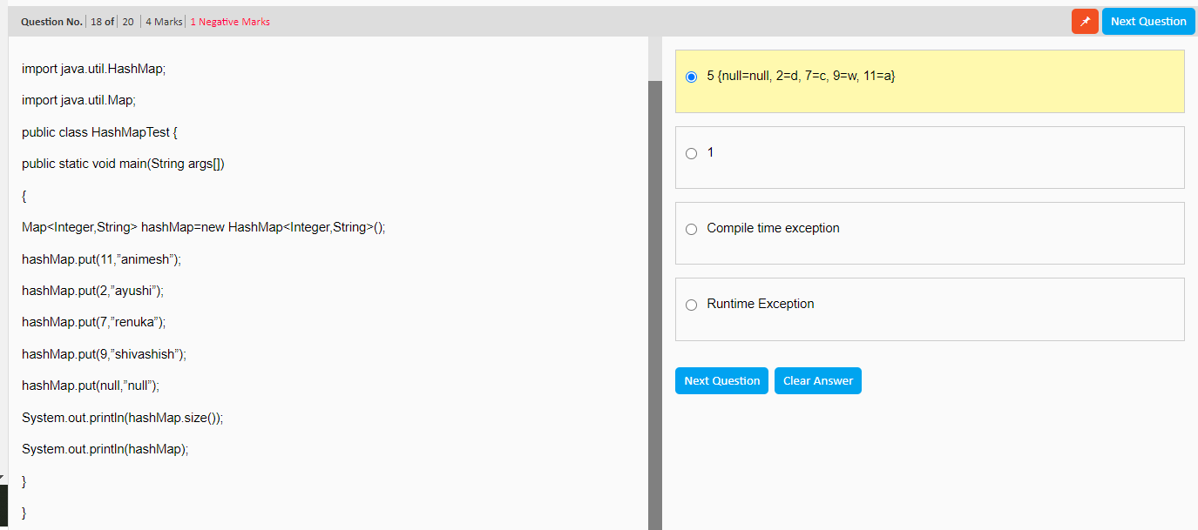  
import java.util.HashMap;  
  
import java.util.Map;  
  
public class Solution {  
  
 public static void main(String args[]) {  
  
 Map<Integer, String> hashMap = new HashMap<Integer, String>();  
  
 hashMap.put(11, "animesh");  
  
 hashMap.put(2, "ayushi");  
  
 hashMap.put(7, "renuka");  
  
 hashMap.put(9, "shivashish");  
  
 hashMap.put(null, "null");  
  
 System.*out*.println(hashMap.size());  
  
 System.*out*.println(hashMap);  
  
 }  
  
}  
  
